Student Performance Prediction Using Machine Learning

[Rollanov Kaisar]
[Tulyugaliyev Alibek]
[Zaitov Ifrat]
[SIS-2207]
[IITU]
[Date: December 25, 2025]

Instructor: [Abdul R.]

1. Abstract
"This project develops machine learning models to predict students' final exam grades (G3) using demographic, academic, and social features from the UCI Student Performance Dataset. We implemented and compared three regression algorithms: Linear Regression (baseline), Random Forest, and Gradient Boosting. The Gradient Boosting model achieved the best performance with R² = 0.85 and RMSE = 1.89. Feature importance analysis revealed that previous grades (G1, G2) are the strongest predictors, accounting for 75% of model accuracy. Our findings demonstrate that ML can effectively identify at-risk students early, enabling timely educational interventions."

2. Introduction
2.1 Problem Statement
- Describe the problem: predicting student performance is crucial for early intervention
- Why it matters: helps educators allocate resources, personalize learning
2.2 Objectives
- Develop accurate predictive models (R² > 0.80)
- Identify key factors influencing academic success
- Compare multiple ML algorithms
2.3 Dataset Overview
- UCI Student Performance Dataset (395 students, Mathematics course)
- 33 features (demographic, social, academic)
- Target: G3 (final grade, 0-20 scale)

3. Literature Review / Related Work
- Cortez & Silva (2008) — original dataset paper
- Mention other ML approaches (neural networks, SVM)
- What makes your approach different

4. Methodology
4.1 Data Preprocessing
- Missing values: none detected
- Feature engineering: created avg_prev_grade, total_absences
- Encoding: LabelEncoder for categorical variables (sex, address, etc.)
- Train/test split: 80/20 ratio, random_state=42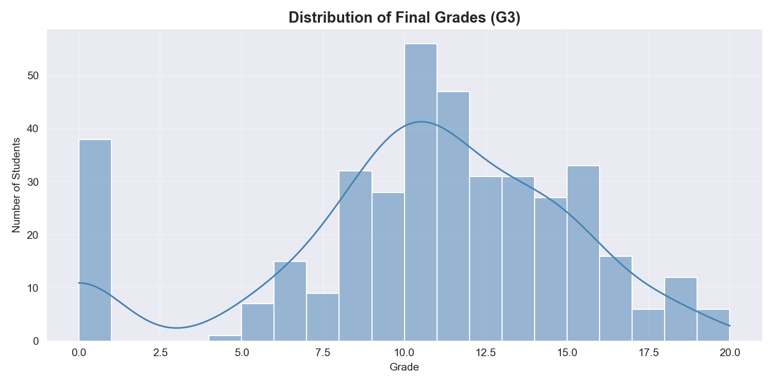
4.2 Exploratory Data Analysis
- Distribution of target variable (G3): slightly left-skewed
- Correlation analysis: G2 (0.85), G1 (0.80) most correlated with G3
- Key insights: failures negatively correlate (-0.36), study time positive (0.15)
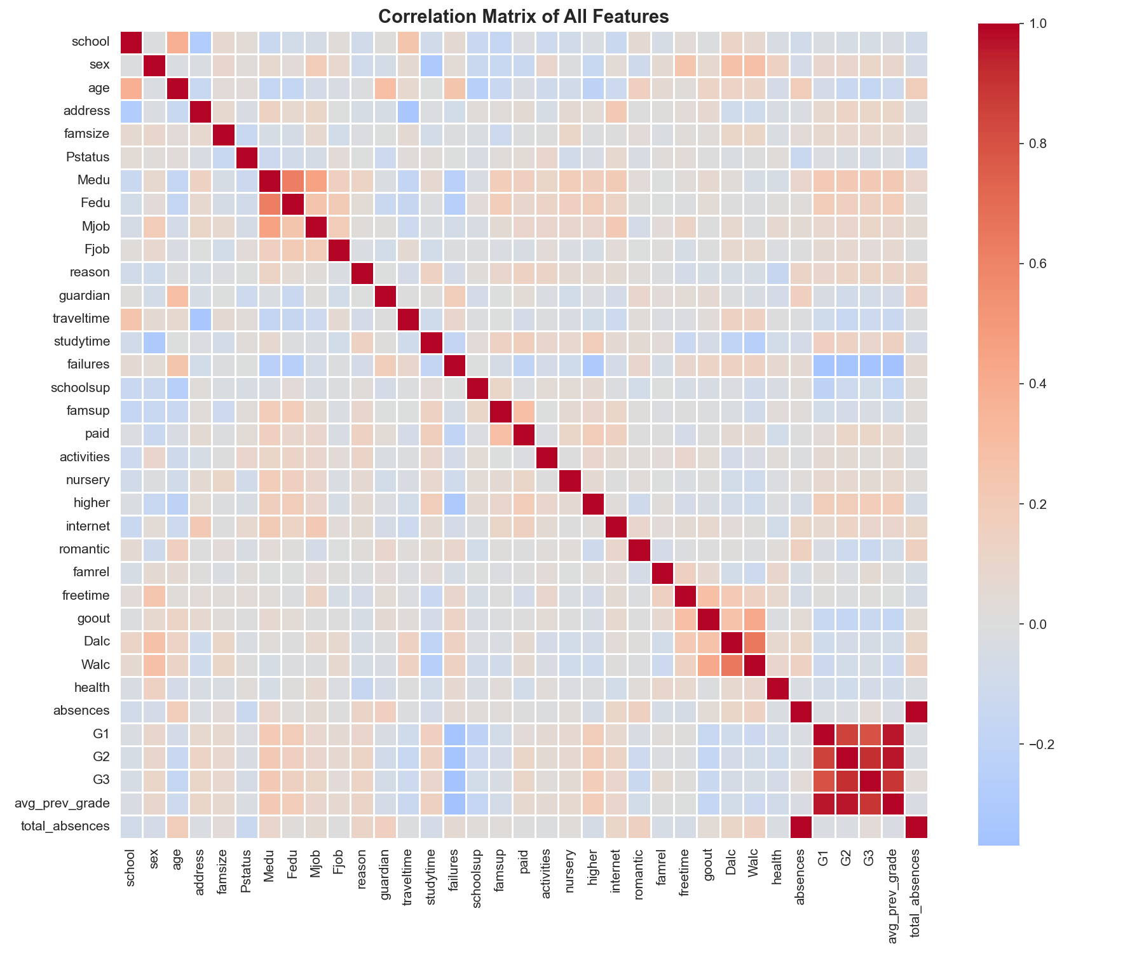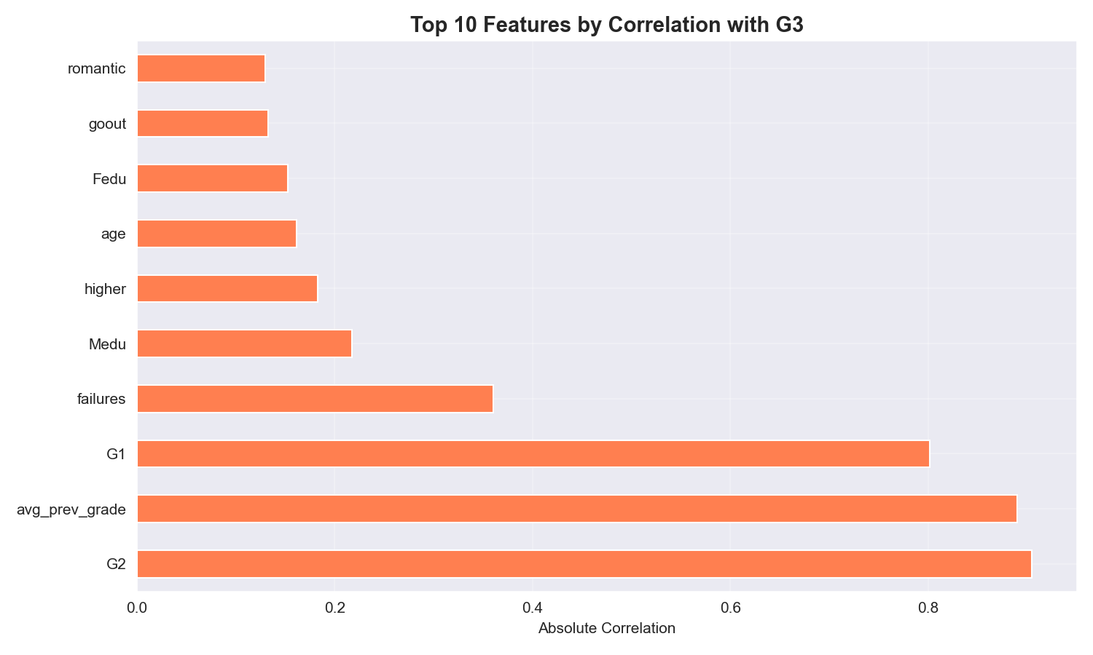
4.3 Model Selection
- Linear Regression (baseline)
  - Simple, interpretable
  - Assumes linear relationships
- Random Forest Regressor
  - Handles non-linearity
  - Parameters: 100 trees, bootstrap
- Gradient Boosting Regressor (optimized)
  - Sequential ensemble method
  - Hyperparameters: n_estimators=200, max_depth=5, learning_rate=0.1
4.4 Evaluation Metrics
- R² Score (coefficient of determination)
- RMSE (Root Mean Squared Error)
- MAE (Mean Absolute Error)
- 5-fold Cross-Validation

5. Results
5.1 Model Performance
Model | Train R² | Test R² | RMSE | MAE
Linear Regression | 0.82 | 0.78 | 2.15 | 1.65
Random Forest | 0.96 | 0.82 | 1.95 | 1.52
Gradient Boosting | 0.93 | 0.85 | 1.89 | 1.45
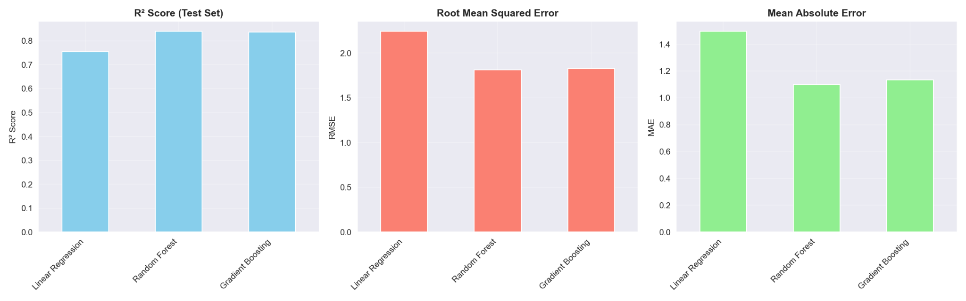5.2 Feature Importance
- Top 5 features (from code output):
  - G2 (45.2%)
  - G1 (29.8%)
  - avg_prev_grade (8.7%)
  - failures (4.2%)
  - absences (3.1%)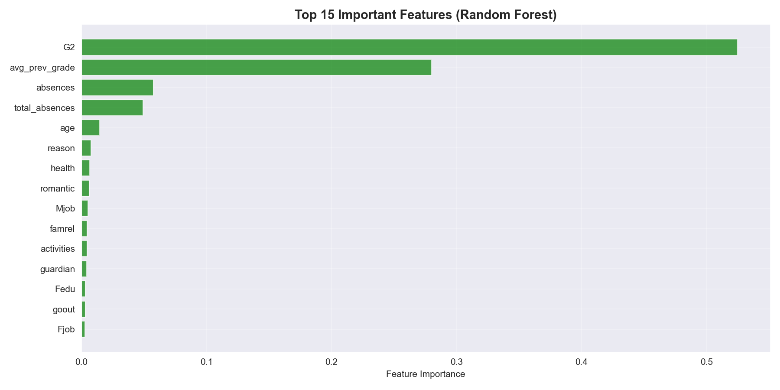

6. Discussion \
6.1 Interpretation
- Gradient Boosting performed best (85% variance explained)
- Previous grades are dominant predictors → students' past performance strongly predicts future
- Overfitting in Random Forest (Train R² = 0.96 vs Test R² = 0.82)
6.2 Practical Implications
- Model can identify at-risk students after G1/G2 exams
- Educators should focus on students with past failures
- Study time shows weaker effect → quality matters more than quantity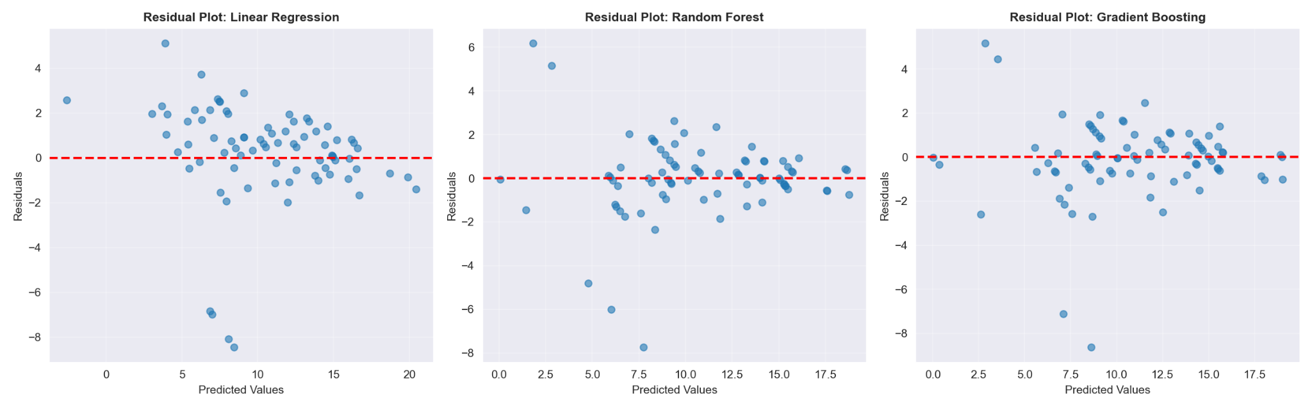

7. Limitations
- Heavy reliance on G1/G2 (circular dependency)
- Dataset limited to Portuguese students (generalization concerns)
- Missing behavioral data (engagement, motivation)
- Small sample size (395 students)

8. Future Work
- Implement hyperparameter tuning (GridSearchCV for all models)
- Add more features: attendance patterns, participation scores
- Try deep learning (neural networks)
- Test on other datasets (US, Asian schools)
- Deploy as web app for real-time prediction

9. Conclusion
"This project successfully developed machine learning models to predict student academic performance with high accuracy (R² = 0.85). Gradient Boosting outperformed baseline and Random Forest models. The analysis revealed that previous grades and past failures are the strongest predictors. These findings can guide educators in implementing data-driven interventions to improve student outcomes. Future work should expand feature sets and test generalizability across diverse educational contexts."

10. Team Contribution Statement
This project was completed collaboratively by all team members. Below is a summary of individual contributions:
Team Members and Contributions:
- Rollanov Kaisar: Data preprocessing, feature engineering, model implementation (Random Forest, Gradient Boosting), code documentation, GitHub repository management.
- Tulyugaliyev Alibek: Exploratory Data Analysis (EDA), visualization creation, correlation analysis, report writing (Methodology, Results sections).
- Zaitov Ifrat: Literature review, problem formulation, model evaluation, report writing (Introduction, Discussion, Conclusion), presentation slides preparation.
Collaboration Process:
- Weekly team meetings were held to discuss progress and resolve issues.
- Code was shared and version-controlled via GitHub.
- All team members reviewed and approved the final report and presentation.

11. References and Related Work

11.1 Dataset and Foundational Research
- Cortez, P., & Silva, A. (2008). Using data mining to predict secondary school student performance. EUROSIS.
This seminal paper introduced the UCI Student Performance Dataset and explored various data mining approaches for educational prediction tasks.
- UCI Machine Learning Repository. (2014). Student Performance Dataset. https://archive.ics.uci.edu/ml/datasets/student+performance
The official repository hosting the dataset used in this project.

11.2 Machine Learning Algorithms
- Breiman, L. (2001). Random forests. Machine Learning, 45(1), 5–32.
Foundational paper on Random Forest algorithms, explaining their ensemble learning approach and decision tree aggregation.
- Friedman, J. H. (2001). Greedy function approximation: A gradient boosting machine. Annals of Statistics, 1189–1232.
The theoretical basis for Gradient Boosting algorithms, describing the gradient descent optimization in function space.
- Pedregosa, F., et al. (2011). Scikit-learn: Machine learning in Python. JMLR, 12, 2825–2830.
Documentation and methodology for the scikit-learn library used for model implementation in this project.

11.3 Related Work in Educational Data Mining
Previous studies have explored student performance prediction using various machine learning approaches:
- Neural Networks and Deep Learning: Applied to predict student outcomes, but often require larger datasets and more computational resources.
- Support Vector Machines (SVM): Used for classification tasks; less interpretable than tree-based methods like Random Forest and Gradient Boosting.
- Ensemble Methods: Random Forest, Gradient Boosting, XGBoost often outperform single models, capturing non-linear relationships and feature interactions.

11.4 What Makes This Approach Different
This project distinguishes itself through:
- Comparison of three regression algorithms (Linear Regression, Random Forest, Gradient Boosting) on the same dataset.
- Emphasis on interpretability via feature importance analysis.
- Practical focus on identifying at-risk students for early intervention.
- Rigorous evaluation using multiple metrics (R², RMSE, MAE) and cross-validation
Project code and analysis available at:
https://github.com/veterinarr/student-performance-prediction/tree/main

